Retry Legacy Order Place Agent:
  - Navigate to Create Transaction:
Application Platform→Process Modeling→Order Tab
Base Document Type: Order
Document Type: Sales Order
Process Type: Order Fulfillment
Transaction
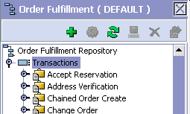
Add new Transaction, Click .
  - Create New Transaction
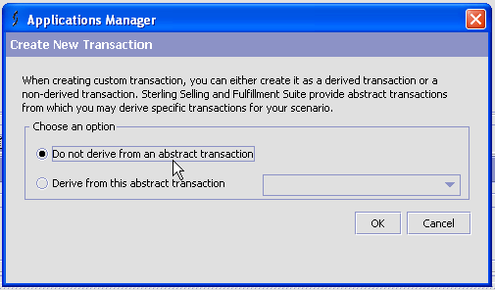
Select ‘Do not derive from an abstract transaction’.
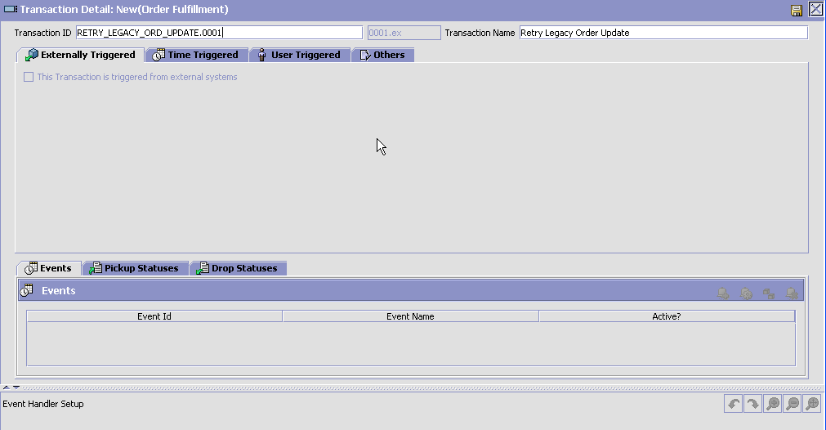
Enter
Transaction ID: RETRY_LEGACY_ORD_UPDATE
Transaction Name: Retry Legacy Order Update
Save the Transaction, Click .
  - Configure Transaction as Time Triggered
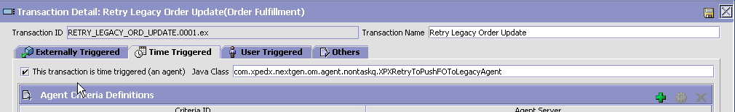
Time Triggered tab:
Check the Check box corresponding to “this transaction is time triggered (as agent)”
Java Class: com.xpedx.nextgen.om.agent.nontaskq.XPXRetryToPushFOToLegacyAgent
Click on to add the Agent:
Configure In ‘Runtime Parameters tab’:
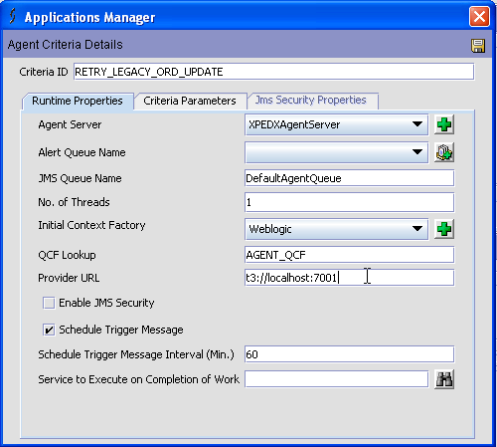
Enter the following:
Criteria ID: RETRY_LEGACY_ORD_UPDATE
Agent Server: XpedxAgentServer [if not there create it by clicking on next to that].
JMS Queue Name: DefaultAgentQueue
No. of Threads:1
Initial Context Factory:Weblogic
QCF Lookup: AGENT_QCF
Provider URL: t3://localhost:7001
Check Schedule Trigger Message
Schedule Trigger Message Interval(Min.):60
Configure Criteria in ‘Criteria Parameters Tab’ :
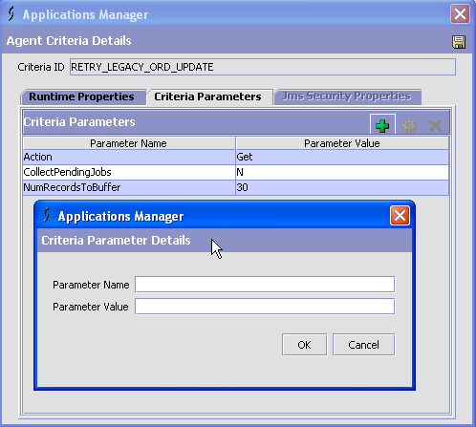
Add following Parameters:
[Name,Value]:
[Action, Get]
[CollectPendingJobs,N]
[NumRecordsToBuffer,30]
Save the Agent Criteria Details, Click .

- Legacy Order Create
  - XPXLegacyOrderCreationService [XPXOrderPlacement Group]
Navigate to Application Platform→Process Modeling→General Tab
Base Document Type: General
Document Type: Sales General
Process Type: General
Services Tab→Click on to add new Service.
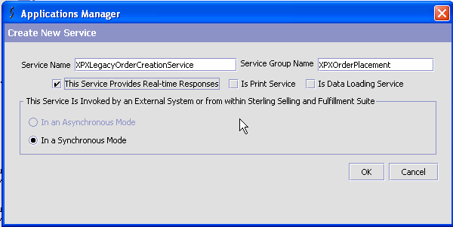

Service Name: XPXLegacyOrderCreationService
Service Group Description: XPXOrderPlacement
Check → This Service Provides Real-Time Responses [this automatically checks In a Synchronous Mode option]
Definition:
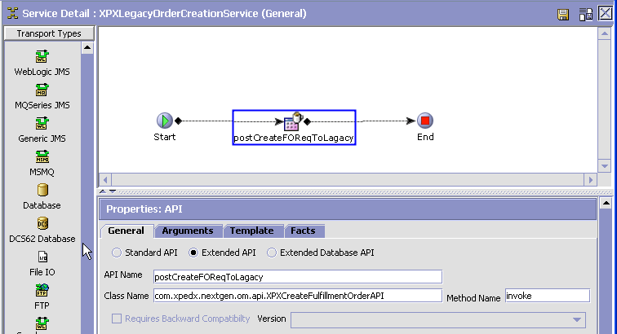
Components:
API
Label: postCreateFOReqToLagacy
Properties: General Tab
Check→Extended API
API Name: postCreateFOReqToLagacy
Class Name: com.xpedx.nextgen.om.api.XPXCreateFulfillmentOrderAPI
Method: invoke
Save the Service, Click .
  - [Condition] Is From Retry Agent [XPX Group]
Navigate to Application Platform→Process Modeling→General Tab
Base Document Type: General
Document Type: Sales General
Process Type: General
Conditions Tab→Click on to add new Condition.
Configuration Details:
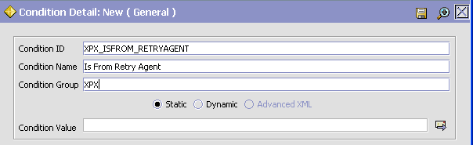
Condition ID: XPX_ISFROM_RETRYAGENT
Condition Name: Is From Retry Agent
Condition Group: XPX
Check→Static
Click on , a popup opens:
Choose Fieldss→General→{Enter Your Own Attribute}
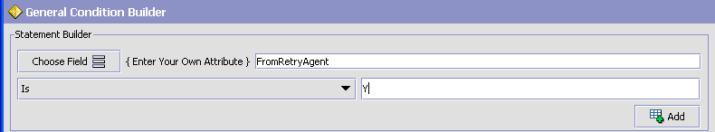
{Enter Your Own Attribute} [FromRetryAgent] [Is][Y]
And Click Add, and Click OK at the bottom
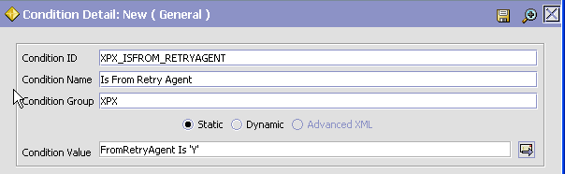
Save the Condition, Click .

  - XPXPostToLegacyOrderCreateService [XPXOrderPlacement Group]
Navigate to Application Platform→Process Modeling→General Tab
Base Document Type: General
Document Type: Sales General
Process Type: General
Services Tab→Click on to add new Service.
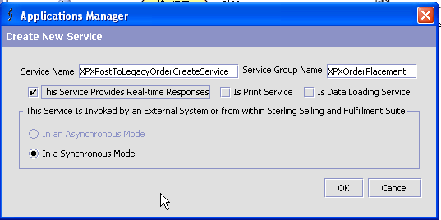

Service Name: XPXPostToLegacyOrderCreateService
Service Group Description: XPXOrderPlacement
Check → This Service Provides Real-Time Responses [this automatically checks In a Synchronous Mode option]
Definition:
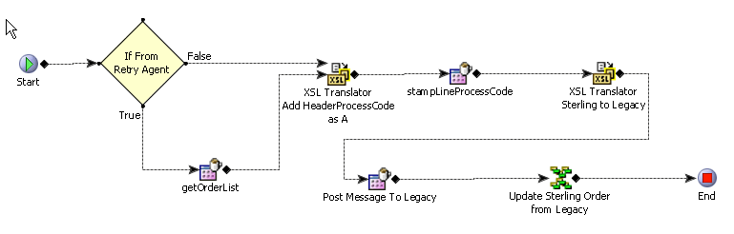
Components:
Component1: Condition [If From Retry Agent]
Label: If From Retry Agent
Properties:
Condition Name: Is From Retry Agent
Condition Linking:
If true:
Link to getOrderList API Component
Else
Link to “XSL Translator Add HeaderProcessCode as A”
Component2: API [getOrderList]
Label: getOrderList
Properties:
- General Tab
Check→Standard API
API Name: getOrderList
Template Tab
Click On XML Template:
Template Root Element:
OrderList
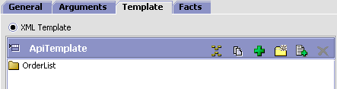
Click on a popup ones, then enter the following XML template and click OK:
<?xml version="1.0" encoding="UTF-8"?>
<OrderList>
<Order BillToID="" CustomerContactID="" CustomerPONo="" EntryType=""
OrderDate="" ReqDeliveryDate="" ShipNode="" Status="">
<Extn ExtnAttentionName="" ExtnBillToName="" ExtnBillToSuffix=""
ExtnCompanyId="" ExtnCustomerDivision="" ExtnCustomerNo=""
ExtnEnvtId="" ExtnGenerationNo="" ExtnHeaderStatusCode=""
ExtnLegacyOrderNo="" ExtnLegacyOrderType=""
ExtnOrdStatCom="" ExtnOrderCode="" ExtnOrderDivision=""
ExtnOrderSpecialCharges="" ExtnOrderTax=""
ExtnShipComplete="" ExtnShipToName="" ExtnShipToSuffix=""
ExtnSourceType="" ExtnSystemIdentifier=""
ExtnTotalOrderFreight="" ExtnTotalOrderValue=""
ExtnTotalShipValue="" ExtnWebConfNum="" ExtnWebHoldFlag=""
ExtnWebHoldReason="" ExtnWillCall=""/>
<PriceInfo Currency=""/>
<OrderLines>
<OrderLine CustomerLinePONo="" CustomerPONo="" LineType=""
OrderedQty="" ShipNode="">
<Extn ExtnBackQtyBase="" ExtnBaseOrderedQty=""
ExtnCustLineAccNo="" ExtnCustLineField1=""
ExtnCustLineField2="" ExtnCustLineField3=""
ExtnLegacyLineNumber="" ExtnLineDescription=""
ExtnLineOrderedTotal="" ExtnLineShippableTotal=""
ExtnLineStatusCode="" ExtnLineType=""
ExtnPriceOverrideFlag="" ExtnPricingUOM=""
ExtnReqBackOrdQty="" ExtnReqShipOrdQty=""
ExtnShipQtyBase="" ExtnUnitPrice="" ExtnWebLineNumber=""/>
<Item CustomerItem="" ItemID="" ItemShortDesc="" UnitOfMeasure=""/>
<OrderLineTranQuantity OrderedQty="" TransactionalUOM=""/>
<Instructions>
<Instruction InstructionText=""/>
</Instructions>
<LineCharges>
<LineCharge ChargeAmount=""/>
</LineCharges>
<Awards>
<Award AwardId=""/>
</Awards>
</OrderLine>
</OrderLines>
<PersonInfoShipTo AddressLine1="" AddressLine2=""
AddressLine3="" City="" Country="" State="" ZipCode=""/>
<PersonInfoBillTo AddressLine1="" AddressLine2=""
AddressLine3="" City="" Country="" State="" ZipCode=""/>
<Instructions>
<Instruction InstructionText=""/>
</Instructions>
</Order>
</OrderList>

Component3: XSL Translator Add HeaderProcessCode as A
Label: XSL Translator Add HeaderProcessCode as A
Properties:
XSL Name: /global/template/xsl/stampHeaderProcessCodeA.xsl
Component4: API [stampLineProcessCode]
Label: stampLineProcessCodes
Properties: General Tab
Check→Extended API
API Name: YIFCustomApi
Class Name: com.xpedx.nextgen.dashboard.XPXStampLinePocessCodes
Method: stampLineProcessCodes

Component5: XSL Translator Sterling to Legacy
Label: XSL Translator Sterling to Legacy
Properties:
XSL Name: /global/template/xsl/orderPlace.xsl

Component6: API [Post Message To Legacy]
Label: Post Message To Legacy
Properties: General Tab
Check→Extended API
API Name: postOrderManageMsgToLegacy
Class Name: com.xpedx.nextgen.common.util.XPXUtils
Method: postOrderManageMsgToLegacy
Component7: Composite Service [Update Sterling Order from Legacy]
Label: Update Sterling Order from Legacy
Properties:
Service Name: XPXLegacyOrderUpdateService

Save the Service, Click .
- Others - None

